**Quick-Pick Authoring Template**

Modulette ID:

Game #:

Game title: Quick-Pick

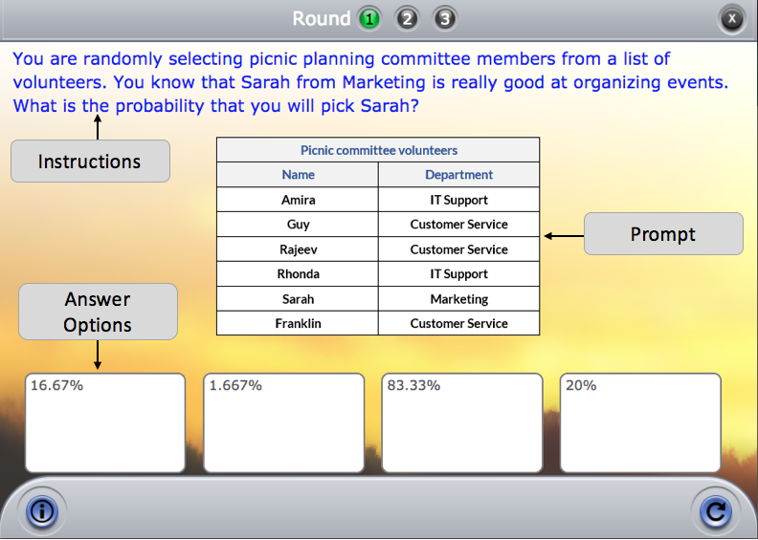

Instructions: [Use if the instructions are the same for the entire game]

Round #

**Instructions:** [Use if the instructions are round specific]

**Prompt:** [Optional--Insert prompt here. Can be text or image]

**Answers and Feedback:**

|  |  |
| --- | --- |
| [Correct answer goes here] | [correct feedback goes here] |
| [incorrect answer option 1] | [general incorrect feedback for all answers, or specific incorrect feedback for this answer] |
| [incorrect answer option 2] | [specific incorrect feedback for this answer] |
| [incorrect answer option 3] | [specific incorrect feedback for this answer] |